Preconditions for the Preliminary Multiple and Single Subject Programs

(1) Limitation on Program Length.
The professional preparation coursework that all candidates are required to complete shall be equivalent to no more than two years of full-time study at the institution.

The limitation applies to postgraduate teacher preparation programs. The limitation does not apply to blended/integrated programs of subject matter preparation and professional preparation teaching internship programs. Reference: Education Code Section 44259 (a) and (b)(3).

Clarification of Program Precondition 1
Program Precondition 1 does not apply to additional courses that are required if a candidate is unable to meet the Commission’s standards of candidate competence and performance by completing the regular professional preparation program.

Examples of Acceptable Evidence
Link to course sequence within a handbook, website, or other authentic program documentation that shows how the program will be completed in no more than two years of full-time study at the institution (or the equivalent).

The University of La Verne LaFetra College of Education offers a 33 semester-unit Multiple Subject or Single Subject Preliminary Credential program. The program is structured to be completed within two academic years of full-time study (equivalent to no more than two years of full-time coursework, consistent with Education Code §44259(a) and (b)(3)).

Program Evidence
Program curriculum and requirements are published in the University Catalog:
https://catalog.laverne.edu/lafetra-college-education/graduate/teacher-education-programs/#degreerequirementstext

The catalog demonstrates the unit total and sequence of coursework for both the Multiple Subject and Single Subject Preliminary Credential programs.

Course Sequence Evidence
A suggested course schedule showing how the program can be completed within two years is available to students during their advising sessions.

(2) Limitation on Student Teaching Prerequisites.
No college or university shall require candidates to complete more than the equivalent of nine semester units of professional preparation courses (as defined in Program Precondition 1) prior to allowing candidates to enroll in student teaching in elementary or secondary schools. This restriction may be increased to the equivalent of twelve semester units if the student teaching prerequisites include study of effective methods of English language development as required by Program Precondition 3. Reference: Education Code Section 44320 (a).

Clarification of Program Precondition 2
Student Teaching is defined as program-coordinated experience in a classroom or school under the direction and supervision of an experienced practitioner to complete program requirements. Other terms sometimes used include field work, field experience, directed teaching, practice teaching, practicum, etc.

Examples of Acceptable Evidence
Link to course sequence within a handbook, website, or other authentic program documentation that shows that no more than nine semester units (or twelve with EL instruction) of credential preparation courses are completed before candidates begin student teaching* experiences in a classroom or school.

The University of La Verne LaFetra College of Education complies with Education Code §44320(a).

Candidates begin early fieldwork during their first semester of enrollment. The first two courses require the following fieldwork hours:

- Multiple Subject: EDUC 425 (20 hours) and EDUC 426 (10 hours)
- Single Subject: EDUC 427 (20 hours) and EDUC 428 (10 hours)

As a result, candidates complete 30 hours of classroom-based fieldwork within the first 8 semester units of professional preparation coursework. This is detailed in the course schedule advising document.

Advanced Supervised Teaching
Prior to enrolling in EDUC 498 – Advanced Supervised Teaching, candidates must complete specified prerequisite coursework and statutory requirements (e.g., TB clearance, Certificate of Clearance, Subject Matter Requirements [SMR], etc.). These prerequisites apply only to enrollment in supervised teaching (i.e., student teaching) and do not delay early clinical field experiences, which begin in the first semester.

Student teaching prerequisites are detailed on the Clinical Teaching website

Document: Student Teaching Prerequisite Checklist

and are published in the University Catalog:

- Multiple Subject: https://education.laverne.edu/multiplesubjectcredential/student-teaching-program-prerequisites/

- Single Subject: https://education.laverne.edu/singlesubjectcredential/student-teaching-program-prerequisites/

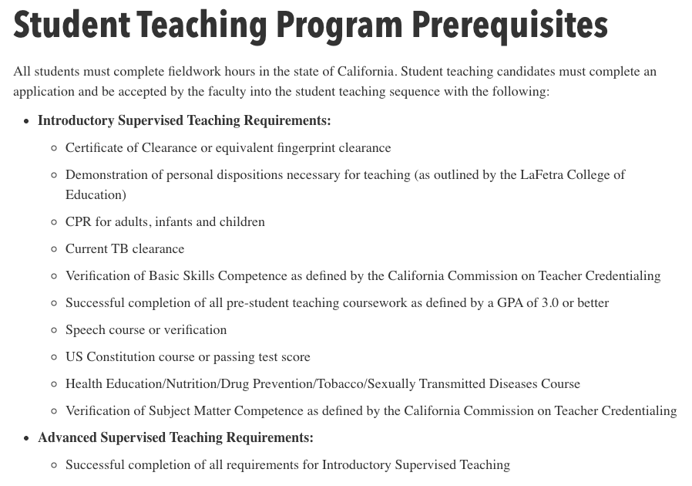

(3) Literacy Instruction:
The program includes the study of effective means of teaching literacy, in accordance with 44259 (b) (4) (A) and (B).

Examples of Acceptable Evidence
For currently approved Preliminary Multiple/Single Subject programs submitting Preconditions in years 1 and 4 of the accreditation cycle: Provide links to syllabi that show when and how candidates will learn and demonstrate knowledge required in Education Code Sections 44259 (b) (4) (A) and (B). Below is an excerpt from the statute. Please refer to the following link to see the full language of the statute: Education Code Sections 44259 (b) (4) (A) and (B).
- ...comprehensive reading instruction that is research based and includes all of the following:
  - The study of organized, systematic, explicit skills including phonemic awareness, direct, systematic, explicit phonics, and decoding skills.
  - A strong literature, language, and comprehension component with a balance of oral and written language.
  - Ongoing diagnostic techniques that inform teaching and assessment.
  - Early intervention techniques.
  - Guided practice in a clinical setting.
- ... “direct, systematic, explicit phonics” means phonemic awareness, spelling patterns, the direct instruction of sound/symbol codes and practice in connected text, and the relationship of direct, systematic, explicit phonics...

Preliminary Multiple Subject

The University of La Verne Preliminary Multiple Subject program provides comprehensive, research-based literacy instruction aligned with Education Code §44259(b)(4)(A) and (B). Literacy preparation is embedded primarily within EDUC 425, EDUC 426, and EDUC 440, and is reinforced through supervised clinical practice and structured assessment processes.

A. Comprehensive Reading Instruction

(a) Organized, Systematic, Explicit Skills
Foundational literacy instruction is delivered through structured, systematic, and explicit coursework in EDUC 425 and EDUC 440.

Instruction includes:
- Print concepts and alphabetic knowledge
- Phonological awareness, including phonemic awareness
- Direct, systematic, explicit phonics instruction
- Sound-symbol correspondence
- Spelling and syllable patterns
- Decoding and encoding
- Orthographic mapping
- Morphology and syntax
- Instruction and practice in connected and decodable text

These elements are documented in the following course materials:
- EDUC 425 Syllabus
- EDUC 440 Syllabus

Candidates engage in modeling, guided practice, independent lesson design, and structured literacy application aligned to the California Dyslexia Guidelines.

(b) Literature, Language, and Comprehension

The program includes a strong literature, language, and comprehension component grounded in the ELA/ELD Framework.

Coursework includes:
- Academic vocabulary development
- Meaning making and text structure
- Reading comprehension lesson design
- Critical literacy
- Writing connected to reading
- Oral and multimedia presentation development

Revisions to strengthen effective expression, peer review, and writing assessment are documented in:
- EDUC 440 Syllabus (Weeks 6, 13–14)
- EDUC 440 Critical Literacy Multimedia Book Talk Assignment

These revisions ensure candidates plan, develop, provide peer feedback, revise, and assess written and oral presentations across genres.

(c) Ongoing Diagnostic Techniques
Candidates are trained to administer, analyze, and apply assessment data to inform literacy instruction.
Assessment preparation includes:
- Phonological awareness assessment
- Phonics assessment
- Fluency assessment
- Screening for dyslexia risk
- Case study analysis of student literacy profiles
- Progress monitoring and instructional planning

These elements are embedded in:
- EDUC 425 Case Study Assignment
- EDUC 440 Case Study Assignment
- EDUC 425 Clinical Practice Overview

Candidates analyze assessment results and develop targeted instructional recommendations aligned to MTSS and structured literacy principles.

(d) Early Intervention Techniques
Early intervention is addressed through:
- MTSS framework instruction
- Tier 1 and Tier 2 literacy planning
- Dyslexia screening and structured literacy intervention
- Collaboration and referral processes

Candidates provide targeted intervention during supervised tutoring experiences documented in:
- EDUC 425 Clinical Practice Overview

District MOUs further specify exposure to screening, diagnostic, and early intervention practices within clinical placements.

(e) Guided Practice in a Clinical Setting
Guided clinical practice is embedded across coursework.

In EDUC 425:
- 15 hours of one-on-one intensive tutoring in foundational skills
- 5 hours of supervisor consultation and guided reflection
- Structured observation and feedback
In EDUC 440:
- 20 hours of supervised classroom-based literacy instruction
- Lesson planning, delivery, and reflection

Clinical instruction and supervision are documented in:
- EDUC 425 Clinical Practice Overview
- EDUC 440 Clinical Practice Overview

B. Direct, Systematic, Explicit Phonics
Consistent with §44259(b)(4)(B), the program prepares candidates to provide direct, systematic, explicit phonics instruction including:
- Phonemic awareness
- Explicit sound-symbol correspondence
- Spelling patterns
- Decoding and encoding
- Practice in connected and decodable text
- Orthographic mapping
- Integration of morphology, syntax, and semantics

Explicit instruction in letter formation, capitalization, and language conventions was strengthened in response to Commission feedback and is documented in:
- PDF of EDUC 425 Week 7 Lecture (Slides 10–11)
- EDUC 440 Lesson Plan Template (including CCSS Language Conventions Standard)

Candidates demonstrate competence through lesson planning, case studies, structured tutoring, peer review activities, and supervised clinical evaluations.

Preliminary Single Subject

The University of La Verne LaFetra College of Education ensures that candidates in the Single Subject teacher preparation program receive preparation in literacy instruction aligned with California literacy standards and Commission expectations.

The Single Subject literacy coursework is designed specifically to prepare candidates to support literacy development within secondary content areas through a disciplinary lens. While the courses use different course numbers than those in the Multiple Subject program, they intentionally focus on literacy instruction as it applies to teaching and learning within a specific subject area.

The required literacy coursework for Single Subject candidates includes:

- EDUC 427 – Language and Literacy, Single Subject
- EDUC 442 – Intermediate Teaching Practices, Single Subject

These courses provide preparation in evidence-based literacy instruction, including literacy development, disciplinary literacy, and strategies to support reading, writing, and language development in secondary content areas.

(4) Assessing Candidates for Subject Matter Competence
The program sponsor has a timely and systematic process for evaluating and notifying candidates of their standing in relation to the subject matter competence requirement. This process includes:
- Providing candidates with clear and accurate information in all advising and application materials about all options available to demonstrate subject matter competence, pursuant to Education Code Section 44259(b)(5)(a), Title 5 Code of Regulations §80096.
- Within the first 60 days of the candidate’s admission, the institution must complete an assessment of each candidate’s standing in relation to demonstration of the subject matter competence requirement, including whether a coursework evaluation will be needed, and notify candidates of that standing.

Examples of Acceptable Evidence
- Link within a handbook, website, or other authentic program documentation that indicates how candidates are provided with clear and accurate information about all options available to demonstrate subject matter competence, pursuant to Education Code Section 44259(b)(5)(a), Title 5 Code of Regulations §80096. This evidence may be within any current authentic candidate materials where requirements are listed.
- Evidence of the program’s process for completing the assessment of a candidate’s standing in relation to demonstration of the subject matter competence requirement and providing candidates with notification of their standing within 60 days of their admission to the program. This notification should include reference to how the candidate has completed the requirement or next steps to completion.

The University of La Verne LaFetra College of Education maintains a timely and systematic process for evaluating and notifying candidates of their standing in relation to the Subject Matter Competence (SMC) requirement in accordance with Education Code §44259(b)(5)(A) and Title 5 §80096.

Clear Communication of Subject Matter Competence Options
Candidates are provided clear and accurate information regarding all Commission-approved options to demonstrate subject matter competence through published admission materials and advising resources.

- Admission Requirements webpage.
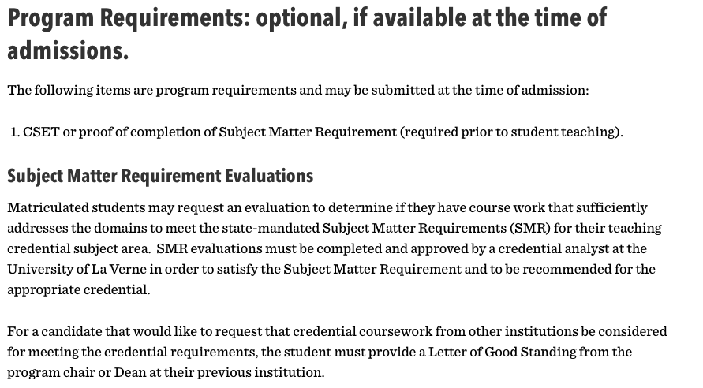

- About TK-12 Education Trailer Bill (AB 130): https://education.laverne.edu/ab-130/
- Candidates also access and submit the Subject Matter Requirement evaluation form:
These materials outline the following Commission-approved methods:
- Completion of a Commission-approved Subject Matter Program
- Passage of a Commission-approved subject matter examination (CSET)
- Successful completion of coursework verified by the Commission-approved preparation program
- Completion of a qualifying degree major
- A combination of approved methods

60-Day Review and Evaluation Process
Within the first 60 days of admission to the credential program, each candidate’s standing relative to the Subject Matter Requirement is evaluated.

Candidates submit the SMR Evaluation Form along with supporting documentation, which may include transcripts, CSET score reports, or course descriptions.

A Credential Analyst reviews the documentation and determines whether:
- The requirement has been satisfied;
- A coursework evaluation is required; or
- Additional steps are necessary.

The review process and submission expectations are described in program handbook
pg 24:
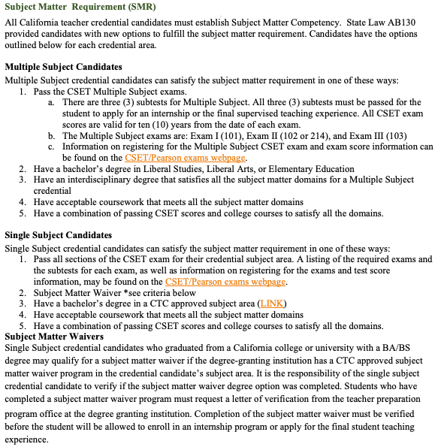

Candidate Notification and Tracking
Candidates are formally notified of their standing following review. If additional coursework or examination is required, candidates receive written notification outlining next steps.
If the Subject Matter Competence requirement has not been met at admission, it is identified in:

- The Student Teaching Prerequisites Form
- The Student Teaching Application

The candidate’s status is documented in the credential file and tracked by the Credential Analysts Office.

(5) Demonstration of Subject Matter Competence
The approved preliminary teacher preparation program sponsor determines that each candidate meets the subject matter requirement prior to being given daily whole class instructional responsibilities in a TK-12 school.

Candidates enrolled in an integrated undergraduate teacher preparation program may begin the daily whole class instruction portion of their student teaching experience before meeting the subject matter requirement. However, all candidates must meet the subject matter requirement before being recommended for their preliminary teaching credential.

A) For Multiple Subject and Single Subject programs, the candidate provides evidence of having demonstrated subject matter competence through one of the following methods:

- Completion of a subject matter program approved by the Commission on the basis of standards of program quality and effectiveness. Reference: Education Code 44259 (b)(5)(A)(i).
- Passage of a Commission-approved subject matter examination. Reference: Education Code 44259 (b)(5)(A)(ii).
- Successful completion of coursework at one or more regionally accredited institutions of higher education that addresses each of the domains of the subject matter requirements adopted by the Commission in the content area of the credential pursuant to Section 44282, as verified by a Commission-approved program of professional preparation. Coursework completed at a community or junior college that is regionally accredited by an accrediting agency listed in subparagraph (A) of paragraph (1) of subdivision (g) of Section 44203 or by the Accrediting Commission for Community and Junior Colleges of the Western Association of Schools and Colleges may count for purposes of this clause. Reference: Education Code 44259 (b)(5)(A)(iii), Title 5 Code of Regulations §80096.
- Successful completion of a baccalaureate or higher degree from a regionally accredited institution of higher education with the following, as applicable.
i. For Single Subject credentials, a major in one of the subject areas in which the Commission credentials candidates, as indicated in Education Code Sections 44259(b)(5)(A)(iv)(I) and 44282 (b), Title 5 Code of Regulations §80096.
ii. For Multiple Subject credentials, a liberal studies, liberal arts, or elementary education major or other degree that includes coursework in the content areas as indicated in Education Code 44259(b)(5)(A)(iv)(II) and 44282 (b), Title 5 Code of Regulations §80096.
- A combination of the methods described in 1, 2, or 3 above that together demonstrate that the candidate has met or exceeded the domains of the subject matter requirements adopted by the Commission. Education Code 44259 (b)(5)(A) (v), and 44282 (b), Title 5 Code of Regulations §80096.

Examples of Acceptable Evidence
Link to tracking materials, checklists, or other authentic program documentation that shows how the program assures that each candidate has demonstrated subject matter proficiency before being given daily whole class instructional responsibilities. The evidence should be clear about when, in the program, demonstration of subject matter occurs.
Please indicate if your student teaching program includes an integrated undergraduate teacher preparation pathway; no additional response is needed for that pathway. For all other pathways, a response is required.

The University of La Verne LaFetra College of Education determines that each candidate meets the Subject Matter Competence requirement prior to being given daily whole class instructional responsibilities in a TK–12 classroom and prior to institutional recommendation for the Preliminary Credential, in accordance with Education Code §44259(b)(5) and Title 5 §80096.

Candidates enrolled in an integrated undergraduate teacher preparation program may begin the daily whole class instruction portion of student teaching before meeting the subject matter requirement. However, all candidates must satisfy the Subject Matter Competence requirement prior to recommendation for the preliminary teaching credential.

Approved Methods for Demonstrating Subject Matter Competence
Candidates may demonstrate subject matter competence through one of the following Commission-approved methods:
- Completion of a Commission-approved Subject Matter Program.
- Passage of a Commission-approved subject matter examination (CSET).
- Successful completion of coursework verified by the Commission-approved preparation program.
- Completion of a qualifying baccalaureate or higher degree major, as applicable.
- A combination of approved methods that together demonstrate competence.

Information describing these approved options is published on the program’s Admission Requirements webpage.

Additional AB 130 and Subject Matter guidance is available at: https://education.laverne.edu/ab-130/

Verification Process Prior to Student Teaching
Candidates complete and submit the Subject Matter Requirement (SMR) Evaluation Form and include supporting documentation (e.g., transcripts, CSET score reports, course descriptions) to support their request. Unofficial reports may be submitted for initial review; however, official transcripts and score reports are required for the credential file.

Subject Matter Requirement (SMR) Evaluation Form

A Credential Analyst evaluates the submitted documentation and verifies whether the Subject Matter Competence requirement has been satisfied.

Completion of the Subject Matter Requirement is required prior to enrollment in Advanced Supervised Teaching and prior to daily whole class instructional responsibility.

Student Teaching prerequisites are published here:
https://education.laverne.edu/multiplesubjectcredential/student-teaching-program-prerequisites/
https://education.laverne.edu/singlesubjectcredential/student-teaching-program-prerequisites/

- The Student Teaching Application

Tracking and Institutional Verification
The candidate’s Subject Matter Competence status is documented in the credential file and tracked by the Credential Analysts Office prior to:
- Assignment of daily whole class instructional responsibilities
- Approval for Advanced Supervised Teaching
- Institutional recommendation for the credential

Candidates who have not satisfied the requirement at admission are notified and the requirement is identified in:
- The Student Teaching Prerequisites Form
- The Student Teaching Application

This systematic review and tracking process ensures that no candidate is assigned daily whole class instructional responsibilities without verified demonstration of subject matter competence.

(6) Completion of Requirements
A college or university or school district that operates a program for the Preliminary Multiple or Single Subject Credential shall determine, prior to recommending a candidate for the credential, that the candidate meets all legal requirements for the credential, including but not limited to: Reference: Education Code Sections 44259 (b) and 44283 (b) (8).

Possession of a baccalaureate or higher degree for Preliminary Multiple Subject credential candidates, and for Preliminary Single Subject candidates, possession of a baccalaureate degree in a subject other than in professional education from a regionally accredited institution

- Completion of Basic Skills Requirement (met by possession of a baccalaureate degree as indicated above)
- Completion of an accredited professional preparation program
- Completion of the subject matter competence requirement
- Demonstration of knowledge of the principles and provisions of the Constitution of the United States
- Passage of the Teaching Performance Assessment
- Passage of the Reading Instruction Competence Assessment (RICA) (for Multiple Subject candidates).

Examples of Acceptable Evidence
Link to evidence (tracking materials, checklists, or other authentic program documentation) that shows the tracking process followed by the program to assure that each candidate has completed each legal requirement of the credential. If this credential recommendation tracking process is housed in an internal database, screenshots of the process can be provided.

The University of La Verne LaFetra College of Education determines, prior to institutional recommendation for the Preliminary Multiple Subject or Single Subject Credential, that each candidate has satisfied all legal requirements in accordance with Education Code §§44259(b) and 44283(b)(8).
Prior to recommendation, the University verifies that candidates have completed the following requirements:

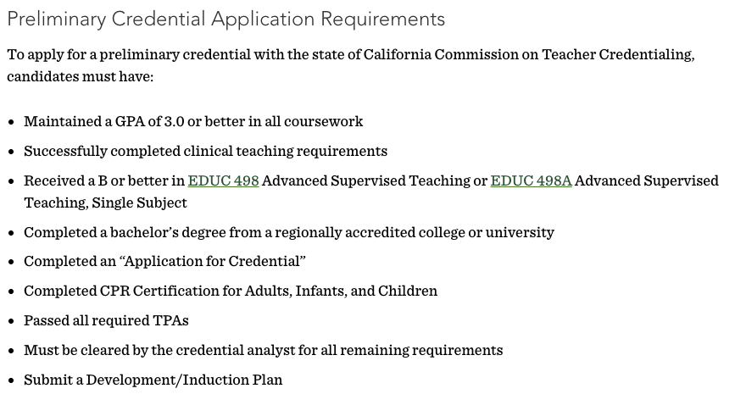

Published Credential Requirements
All credential requirements are published in the University Catalog:

- Multiple Subject
- Single Subject

Verification and Tracking Process
The University has established a systematic credential verification process administered by trained Credential Analysts.

All program coursework is documented on the candidate’s official transcript. At the conclusion of the program, a Credential Analyst conducts a final review using the Degree Program Evaluation (DPE) system and MyDegree Tracker (Multiple Subject & Single Subject) to verify completion of all credential requirements prior to recommendation.

Information regarding the tracking system is described in the program handbook beginning page 22:

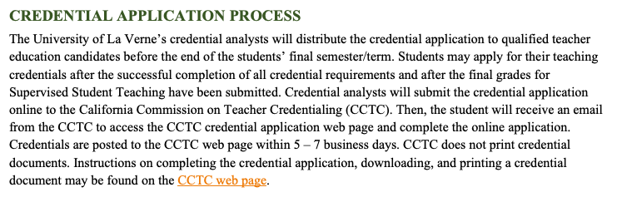

- Candidates attend a student teaching orientation meeting.
- Candidates fill out Part one of the supervised teaching application.
- CT staff review the application to ensure candidates are eligible for supervised teaching.
- Candidates are sent a link to fill out the second part of the supervised teaching application.
- Placements are secured and candidates are informed.

MyDegree Tracker serves as the internal tracking system for degree requirements, course sequencing, and candidate progress. Access is limited to the student and designated faculty advisors. The Credential Analyst verifies completion of all statutory and program requirements prior to submission of the institutional recommendation to the Commission.

No candidate is recommended for the Preliminary Credential until all legal, statutory, and programmatic requirements have been fully satisfied and documented.

