Preconditions for the Preliminary Education Specialist Program

- Literacy Instruction.
The program includes the study of effective means of teaching literacy, in accordance with 44259 (b)(4)(A) and (B).

Evidence Required
For institutions in IIA and for currently approved Preliminary Education Specialist programs submitting Preconditions in years 1 and 4 of the accreditation cycle: Provide links to syllabi that show when and how candidates will learn and demonstrate knowledge required in Education Code Sections 44259 (b) (4) (A) and (B): Please refer to the following link to see the full language of the statute: Education Code Sections 44259 (b) (4) (A) and (B).
- ...comprehensive reading instruction that is research based and includes all of the following:
  - The study of organized, systematic, explicit skills including phonemic awareness, direct, systematic, explicit phonics, and decoding skills.
  - A strong literature, language, and comprehension component with a balance of oral and written language.
  - Ongoing diagnostic techniques that inform teaching and assessment.
  - Early intervention techniques.
  - Guided practice in a clinical setting.
- ... “direct, systematic, explicit phonics” means phonemic awareness, spelling patterns, the direct instruction of sound/symbol codes and practice in connected text, and the relationship of direct, systematic, explicit phonics...

The University of La Verne Preliminary Education Specialist (MMSN and ESN) programs provide comprehensive, research-based literacy instruction aligned with Education Code §44259(b)(4)(A) and (B). Literacy preparation is embedded primarily within EDUC 425, EDUC 428, EDUC 440, SPED 421, and SPED 422, and is reinforced through supervised clinical practice and structured assessment processes.

A. Comprehensive Reading Instruction

(a) Organized, Systematic, Explicit Skills
Foundational literacy instruction is delivered through structured, systematic, and explicit coursework in EDUC 425 and EDUC 440.

Instruction includes:
- Print concepts and alphabetic knowledge
- Phonological awareness, including phonemic awareness
- Direct, systematic, explicit phonics instruction
- Sound-symbol correspondence
- Spelling and syllable patterns
- Decoding and encoding
- Orthographic mapping
- Morphology and syntax
- Instruction and practice in connected and decodable text

These elements are documented in the following course materials:
- EDUC 425 Syllabus
- EDUC 440 Syllabus

Candidates engage in modeling, guided practice, independent lesson design, and structured literacy application aligned to the California Dyslexia Guidelines.

(b) Literature, Language, and Comprehension
The program includes a strong literature, language, and comprehension component grounded in the ELA/ELD Framework.

Coursework includes:
- Academic vocabulary development
- Meaning making and text structure
- Reading comprehension lesson design
- Critical literacy
- Writing connected to reading
- Oral language development
- Designated and Integrated ELD lesson planning

Revisions to strengthen effective expression, writing support strategies, and academic language development are documented in:

- EDUC 428 Syllabus
- EDUC 440 Syllabus

These elements ensure candidates plan, develop, scaffold, and assess written and oral language development for students with diverse learning needs, including multilingual learners and students with disabilities.

(c) Ongoing Diagnostic Techniques
Candidates are trained to administer, analyze, and apply assessment data to inform literacy instruction and intervention.

Assessment preparation includes:
- Phonological awareness assessment
- Phonics assessment
- Fluency assessment
- Screening for dyslexia risk
- Case study analysis of student literacy profiles
- Progress monitoring and instructional planning within MTSS

These elements are embedded in:
- EDUC 425 Case Study Assignment
- EDUC 440 Case Study Assignment
- SPED 422 Case Study Assignment
- EDUC 425 Clinical Practice Overview

Candidates analyze assessment results and develop targeted instructional and intervention plans aligned to MTSS, IEP goals, and structured literacy principles.

(d) Early Intervention Techniques
Early intervention is addressed through:
- MTSS framework instruction
- Tier 1, Tier 2, and Tier 3 literacy planning
- Dyslexia screening and structured literacy intervention
- Supplemental and intensive intervention aligned to IEP goals
- Collaboration and referral processes

Candidates provide targeted intervention during supervised tutoring and small-group instructional experiences documented in:
- EDUC 425 Clinical Practice Overview
- SPED 421 Literacy Profile Assignment

District MOUs further specify exposure to screening, diagnostic, and early intervention practices within clinical placements.

(e) Guided Practice in a Clinical Setting
Guided clinical practice is embedded across coursework.

In EDUC 425 (20 hours):
- Candidates are required to teach 1 lesson and collect case study data on one student.
- Candidates are required to reflect on the experiences and are provided feedback by the course instructor.

In EDUC 440 (20 hours):
- Candidates will conduct guided observations, teach 2 lessons, and collect case study data on one student.

Clinical instruction and supervision are documented in:
- EDUC 425 Clinical Practice Overview
- EDUC 440 Clinical Practice Overview

B. Direct, Systematic, Explicit Phonics
Consistent with §44259(b)(4)(B), the program prepares candidates to provide direct, systematic, explicit phonics instruction including:
• Phonemic awareness
• Explicit sound-symbol correspondence
• Spelling patterns
• Decoding and encoding
• Practice in connected and decodable text
• Orthographic mapping
• Integration of morphology, syntax, and semantics

Explicit instruction in letter formation, language conventions, and structured literacy intervention strategies is documented in:
- EDUC 425 Syllabus
- EDUC 440 Lesson Plan Template

Candidates demonstrate competence through lesson planning, structured tutoring, literacy profile analysis, case studies, and clinical evaluations.

(2) Assessing Candidates for Subject Matter Competence
The program sponsor has a timely and systematic process for evaluating and notifying candidates of their standing in relation to the subject matter competence requirement. This process includes:
- Providing candidates with clear and accurate information in all advising and application materials about all options available to demonstrate subject matter competence, pursuant to Education Code Section 44259(b)(5)(a), Title 5 Code of Regulations §80096.
- Within the first 60 days of the candidate’s admission, the institution must complete an assessment of each candidate’s standing in relation to demonstration of the subject matter competence requirement, including whether a coursework evaluation will be needed, and notify candidates of that standing.

Evidence Required
- Link within a handbook, website, or other authentic program documentation that indicates how candidates are provided with clear and accurate information about all options available to demonstrate subject matter competence, pursuant to Education Code Section 44259(b)(5)(a), Title 5 Code of Regulations §80096. This evidence may be within any current authentic candidate materials where requirements are listed.
- Evidence of the program’s process for completing the assessment of a candidate’s standing in relation to demonstration of the subject matter competence requirement and providing candidates with notification of their standing within 60 days of their admission to the program. This notification should include reference to how the candidate has completed the requirement or next steps to completion.

The University of La Verne LaFetra College of Education maintains a timely and systematic process for evaluating and notifying Education Specialist candidates of their standing in relation to the Subject Matter Competence (SMC) requirement in accordance with Education Code §44259(b)(5)(A) and Title 5 §80096.

Clear Communication of Subject Matter Competence Options
Candidates are provided clear and accurate information regarding all Commission-approved options to demonstrate subject matter competence through published admission materials and advising resources.
- Admission Requirements webpage:
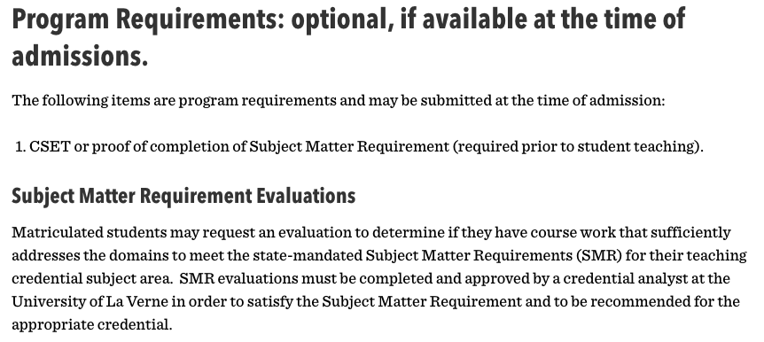
- About TK-12 Education Trailer Bill (AB 130): https://education.laverne.edu/ab-130/
- Candidates also access and submit the Subject Matter Requirement evaluation form
These materials outline the following Commission-approved methods:
- Completion of a Commission-approved Subject Matter Program
- Passage of a Commission-approved subject matter examination (CSET)
- Successful completion of coursework verified by the Commission-approved preparation program
- Completion of a qualifying degree major
- A combination of approved methods

60-Day Review and Evaluation Process

Within the first 60 days of admission to the credential program, each candidate’s standing relative to the Subject Matter Requirement is evaluated.

Candidates submit the SMR Evaluation Form along with supporting documentation, which may include transcripts, CSET score reports, or course descriptions.

A Credential Analyst reviews the documentation and determines whether:
- The requirement has been satisfied;
- A coursework evaluation is required; or
- Additional steps are necessary.

The review process and submission expectations are described in program handbook
pg 25:
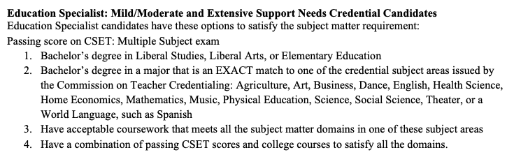

Candidate Notification and Tracking
Candidates are formally notified of their standing following review. If additional coursework or examination is required, candidates receive written notification outlining next steps.
If the Subject Matter Competence requirement has not been met at admission, it is identified in:
- The Student Teaching Prerequisites
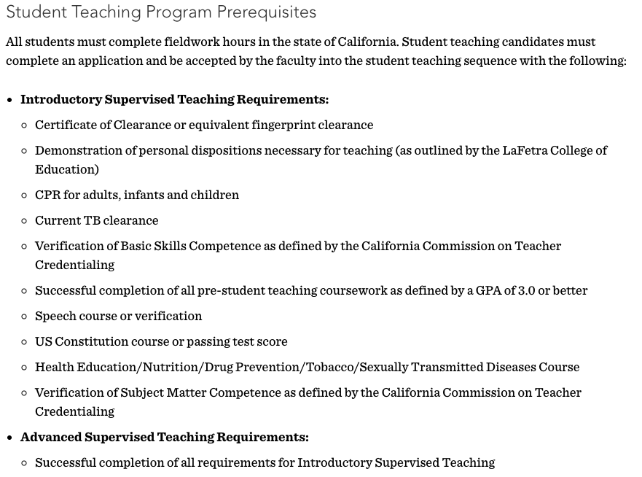

- The Student Teaching Application

The candidate’s status is documented in the credential file and tracked by the Credential Analysts Office.

(3) Demonstration of Subject Matter Competence
The approved preliminary teacher preparation program sponsor determines that each candidate meets the subject matter requirement prior to being given daily whole class instructional responsibilities in a TK-12 school.

Candidates enrolled in an integrated undergraduate teacher preparation program may begin the daily whole class instruction portion of their student teaching experience before meeting the subject matter requirement. However, all candidates must meet the subject matter requirement before being recommended for their preliminary teaching credential.

a. For Education Specialist programs, the candidate provides evidence of having demonstrated subject matter competence through one of the following methods:

- Completion of a subject matter program approved by the Commission on the basis of standards of program quality and effectiveness. Reference: Education Code 44259 (b)(5)(A)(i).
- Passage of a Commission-approved subject matter examination. Reference: Education Code 44259 (b)(5)(A)(ii).
- Successful completion of coursework at one or more regionally accredited institution of higher education that addresses each of the domains of the subject matter requirements adopted by the Commission in the content area of the credential pursuant to Section 44282, as verified by a Commission-approved program of professional preparation. Coursework completed at a community or junior college that is regionally accredited by an accrediting agency listed in subparagraph (A) of paragraph (1) of subdivision (g) of Section 44203 or by the Accrediting Commission for Community and Junior Colleges of the Western Association of Schools and Colleges may count for purposes of this clause. Reference: Education Code 44259 (b)(5)(A)(iii), Title 5 Code of Regulations §80096.
- Successful completion of a baccalaureate or higher degree from a regionally accredited institution of higher education with either a major in one of the subject areas in which the Commission credentials candidates or a liberal studies, liberal arts, or elementary education, or other major that includes coursework in the content areas pursuant to subdivision (b) of Section 44282, or identified in Title 5 Code of Regulations §80096.
i. For Single Subject credentials, a major in one of the subject areas in which the Commission credentials candidates, as indicated in Education Code Sections 44259(b)(5)(A)(iv)(I) and 44282 (b).
ii. For Multiple Subject credentials, a liberal studies major or other degree that includes coursework in the content areas as indicated in Education Code 44259(b)(5)(A)(iv)(II) and 44282 (b).
- A combination of the methods described in 1, 2, or 3 above that, together, demonstrate that the candidate has met or exceeded the domains of the subject matter requirements adopted by the Commission. Education Code 44259 (b)(5)(A)(v), 44282 (b), Title 5 Code of Regulations §80096.

Evidence Required
Link to tracking materials, checklists, or other authentic program documentation that shows how the program assures that each candidate has demonstrated subject matter proficiency before being given daily whole class instructional responsibilities. The evidence should be clear about when, in the program, demonstration of subject matter occurs.
Please indicate if your student teaching program includes an integrated undergraduate teacher preparation pathway; no additional response is needed for that pathway. For all other pathways, a response is required.

The University of La Verne LaFetra College of Education verifies that each Education Specialist candidate has demonstrated subject matter competence prior to being given daily whole-class instructional responsibilities in a TK–12 setting.

Candidates enrolled in an integrated undergraduate pathway (if applicable) may begin portions of supervised clinical practice prior to completion of the subject matter requirement; however, all candidates must satisfy the subject matter requirement prior to recommendation for the Preliminary Education Specialist Credential.

Commission-Approved Methods
Education Specialist candidates demonstrate subject matter competence through one or a combination of the following Commission-approved methods:
- Completion of a Commission-approved subject matter program
- Passage of a Commission-approved subject matter examination (CSET)
- Successful completion of coursework evaluated under AB 130
- Completion of a qualifying baccalaureate or higher degree major
- A combination of approved methods demonstrating alignment to subject matter domains

Information describing these approved options is published on the program’s Admission Requirements webpage.

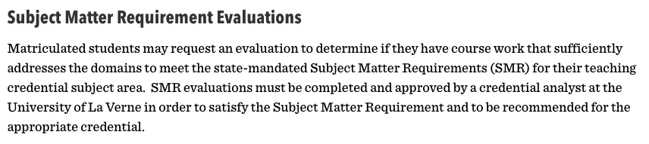

Additional AB 130 and Subject Matter guidance is available at: https://education.laverne.edu/ab-130/

Verification Process Prior to Student Teaching
Candidates complete and submit the Subject Matter Requirement (SMR) Evaluation Form and include supporting documentation (e.g., transcripts, CSET score reports, course descriptions) to support their request. Unofficial reports may be submitted for initial review; however, official transcripts and score reports are required for the credential file.

Subject Matter Requirement (SMR) Evaluation Form

A Credential Analyst evaluates the submitted documentation and verifies whether the Subject Matter Competence requirement has been satisfied.

Completion of the Subject Matter Requirement is required prior to enrollment in Advanced Supervised Teaching and prior to daily whole class instructional responsibility.

Student Teaching prerequisites are published here:

- The Student Teaching Application
- Program handbook pg 17:

Tracking and Institutional Verification
The candidate’s Subject Matter Competence status is documented in the credential file and tracked by the Credential Analysts Office prior to:
- Assignment of daily whole class instructional responsibilities
- Approval for Advanced Supervised Teaching
- Institutional recommendation for the credential

Candidates who have not satisfied the requirement at admission are notified and the requirement is identified in:
- Program handbook pg 17:

- The Student Teaching Application

This systematic review and tracking process ensures that no candidate is assigned daily whole class instructional responsibilities without verified demonstration of subject matter competence.

(4) Completion of Requirements
A college or university or school district that operates a program for the Preliminary Multiple or Single Subject Credential shall determine, prior to recommending a candidate for the credential, that the candidate meets all legal requirements for the credential, including but not limited to: Reference: Education Code Sections 44259 (b) and 44283 (b) (8).

- Possession of a baccalaureate or higher degree from a regionally accredited institution
- Satisfaction of the Basic Skills Requirement
- Completion of an accredited professional preparation program
- Completion of the subject matter competence requirement
- Demonstration of knowledge of the principles and provisions of the Constitution of the United States
- Passage of the Reading Instruction Competence Assessment (RICA)
- Passage of a Commission-approved Teaching Performance Assessment (for candidates enrolling after July 1, 2022)

Evidence Required
Link to evidence (tracking materials, checklists, or other authentic program documentation) that shows the tracking process followed by the program to assure that each candidate has completed each legal requirement of the credential. If this credential recommendation tracking process is housed in an internal database, screenshots of the process can be provided.

The University of La Verne LaFetra College of Education determines, prior to recommending a candidate for the Preliminary Education Specialist Credential, that the candidate has satisfied all legal and program requirements in accordance with Education Code §§44259(b) and 44283(b)(8).

Prior to recommendation, candidates must complete the following:

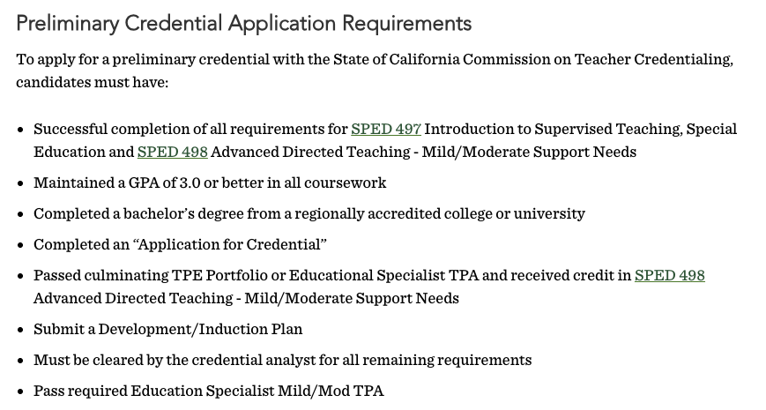

Verification and Tracking Process
The University has established a systematic credential verification process administered by trained Credential Analysts.

All program coursework is documented on the candidate’s official transcript. At the conclusion of the program, a Credential Analyst conducts a final review using the Degree Program Evaluation (DPE) system and MyDegree Tracker to verify completion of all credential requirements prior to recommendation.

Information regarding the tracking system is described in the program handbook beginning page 22:

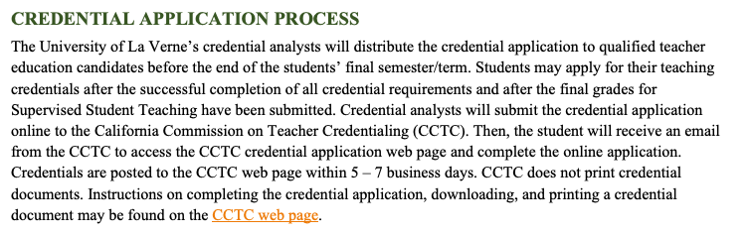

- Candidates attend a student teaching orientation meeting.
- Candidates fill out Part one of the supervised teaching application.
- CT staff review the application to ensure candidates are eligible for supervised teaching.
- Candidates are sent a link to fill out the second part of the supervised teaching application.
- Placements are secured and candidates are informed.

Only candidates who have satisfied all statutory and program requirements are recommended for the Preliminary Education Specialist Credential.

