Preconditions for the Education Specialist Intern

- Bachelor's Degree Requirement.
Candidates admitted to internship programs must hold baccalaureate degrees or higher from a regionally accredited institution of higher education.
Reference: Education Code Sections 44325, 44326, and 44453.

Evidence Required
Link to admission requirements on program website, admission form/checklist, specific page in handbook, or other authentic program documentation that indicates that candidates admitted into the internship program must hold a baccalaureate degree or higher from a regionally accredited institution of higher education.

All candidates admitted into the University of La Verne LaFetra College of Education internship programs hold a bachelor’s degree or higher from a regionally accredited institution of higher education, or in the case of international candidates, a Commission-approved equivalent.

Degree verification occurs prior to admission through official transcript review and is required before recommendation for the Intern Credential. This requirement is documented in the Intern Credential Application, which includes verification of the bachelor’s degree prior to internship eligibility.

The Intern Credential Application requires confirmation that the candidate’s bachelor’s degree has been posted and verified by the Credential Analyst prior to internship recommendation.

(2) Demonstration of Subject Matter Competence
Each Education Specialist Intern must demonstrate subject matter competence prior to being recommended for the intern credential through one of the following methods:
  - Completion of a subject matter program approved by the Commission on the basis of standards of program quality and effectiveness. Reference: Education Code 44259 (b)(5)(A)(i).
  - Passage of a Commission-approved subject matter examination. Reference: Education Code 44259 (b)(5)(A)(ii).
  - Successful completion of coursework at one or more regionally accredited institutions of higher education that addresses each of the domains of the subject matter requirements adopted by the Commission in the content area of the credential pursuant to Section 44282, as verified by a Commission-approved program of professional preparation. Coursework completed at a community or junior college that is regionally accredited by an accrediting agency listed in subparagraph (A) of paragraph (1) of subdivision (g) of Section 44203 or by the Accrediting Commission for Community and Junior Colleges of the Western Association of Schools and Colleges may count for purposes of this clause. Reference: Education Code 44259 (b)(5)(A)(iii), Title 5 Code of Regulations §80096.
  - Successful completion of a baccalaureate or higher degree from a regionally accredited institution of higher education with either a major in one of the subject areas in which the Commission credentials candidates or a liberal studies or other major that includes coursework in the content areas pursuant to subdivision (b) of Section 44282, or identified in Title 5 Code of Regulations §80096.
  - Demonstration that the candidate, through a combination of the methods described in 1, 2, or 3 above, has met or exceeded each of the domains of the subject matter requirements adopted by the Commission in the content area of the credential pursuant to Section 44265, Title 5 Code of Regulations §80096.
NOTES:
- Verification of subject-matter competence is not required for the area of Early Childhood Special Education.

Evidence Required
Link to admission requirements on program website, admission form/checklist, specific page in handbook, or other authentic program documentation that indicates that candidates must have demonstrated the subject matter requirement competence prior to being recommended for the intern credential.

The University of La Verne LaFetra College of Education verifies that each intern candidate has demonstrated subject matter competence prior to being issued an Intern Credential and prior to assuming daily whole-class instructional responsibilities.

Intern candidates submit documentation verifying subject matter competence, including test scores, transcripts, or coursework evaluation materials. Credential analysts review submitted documentation and verify that the requirement has been satisfied before the candidate is recommended for the Intern Credential.

Verification procedures and candidate documentation requirements are provided in the following program materials:

- Intern Admission Requirements Page
- Intern Credential Application
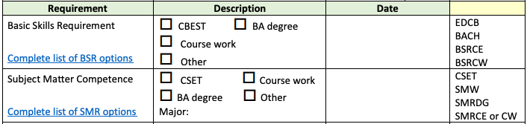
- Subject Matter Requirement (SMR) Evaluation Form

These documents outline the acceptable methods for demonstrating subject matter competence and the program’s verification process prior to internship recommendation.

(3) Pre-Service Requirement
Each Multiple and Single Subject Internship program must include a minimum of 120 clock hour (or the semester or quarter unit equivalent) pre-service component which includes foundational preparation in:
- foundational preparation in pedagogy including classroom management and planning,
- reading/language arts,
- specialty specific pedagogy,
- human development, and
- teaching English Learners.

Evidence Required
Link to the minimum 120 clock hour pre-service requirements in program website, specific page in handbook, admission form/ checklist, course descriptions, or other authentic program documentation that provides evidence of the preparation of interns in each of the listed preservice components (a) – (e).

Education Specialist Internship Program (MMSN and ESN)

Each Education Specialist Internship program must include a minimum of 120 clock hours of pre-service preparation prior to beginning classroom teaching.

The University of La Verne LaFetra College of Education Education Specialist Internship Programs for Mild-Moderate Support Needs (MMSN) and Extensive Support Needs (ESN) provide 180 clock hours of pre-service preparation and 75 hours of fieldwork, exceeding the Commission minimum requirement of 120 clock hours.

Candidates in both the MMSN and ESN internship pathways complete the following coursework prior to serving as teacher of record:

Course | Clock Hours | Fieldwork Hours
SPED 420 Foundations of Inclusive Education | 45 | 10
SPED 421 Literacy Assessment & Intervention Practicum I | — | 15
SPED 430 Assessment Practices and IEP Development | 45 | 20
EDUC 425 Language and Literacy | 45 | 20
EDUC 428 Introductory Teaching Practices | 45 | 10
Total | 180 | 75

These courses prepare candidates in:

- foundational pedagogy including classroom management and instructional planning
- reading and literacy instruction
- special education pedagogy and instructional strategies
- human development and learner variability
- instructional practices supporting English learners

Evidence
- Intern Teaching Website: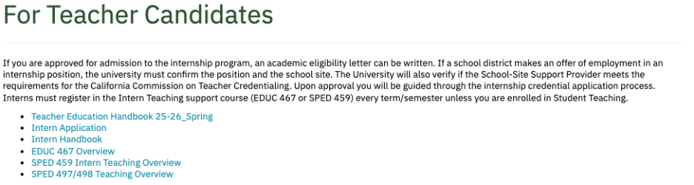
Internship Application
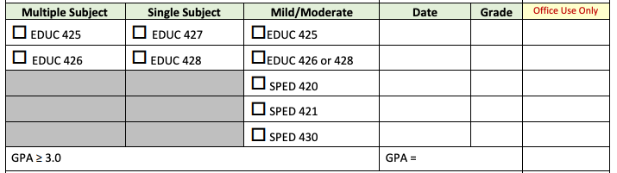

- Intern Program Handbook

(4) Professional Development Plan
The employing district has developed and implemented a Professional Development Plan for interns in consultation with a Commission-approved program of teacher preparation. The plan shall include all of the following:
- Provisions for an annual evaluation of the intern.
- A description of the courses to be completed by the intern, if any
- A plan for the completion of preservice or other clinical training, if any, including student teaching.
- Additional instruction during the first semester of service, for interns teaching in kindergarten or grades 1 to 6 inclusive, in child development and teaching methods, and special education programs for pupils with mild and moderate disabilities.
- Instruction, during the first year of service, for interns teaching children in bilingual classes in the culture and methods of teaching bilingual children, and instruction in the etiology and methods of teaching children with mild and moderate disabilities.

Evidence Required
Link to an explanation of Professional Development Plan or blank Professional Development Plan located on program website, specific page in handbook, or other authentic program documentation that includes components (a) – (e), as applicable, to the intern program.

The University of La Verne LaFetra College of Education places interns only in districts that have developed and implemented a Professional Development Plan for interns in consultation with a Commission-approved program of teacher preparation and have a signed agreement with the University acknowledging the internship program requirements.

The Professional Development Plan includes structured support and supervision for interns through collaboration between the University and the employing district. Support includes:
- Weekly observations for teacher education interns and biweekly observations for special education interns conducted by University Supervisors
- Two observations conducted by the school-site support provider
- Completion of an induction plan
- A minimum of two hours of conference time verified by the school-site support provider through a contact log
- Weekly or biweekly lesson reflection and analysis completed by the intern in relation to observed instruction

Documentation of adherence to the elements of the Professional Development Plan and intern supervision expectations are provided in the following program materials:
- University/District Fieldwork Agreement (page 6-7) 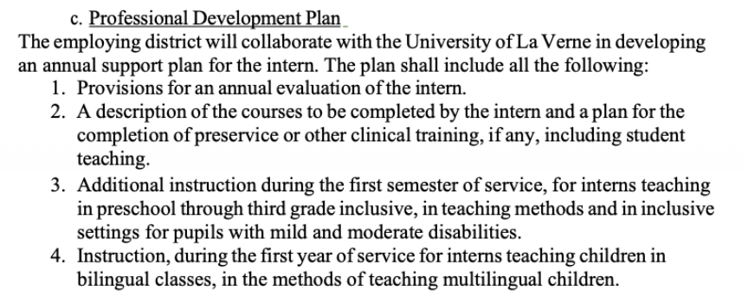

- Intern Teaching Website:
SPED 459 Intern Syllabus

(a) Provisions for an annual evaluation of the intern
Interns are evaluated at the end of each semester on the Teacher Performance Expectations, with a final evaluation completed both by the University Supervisor and the site support provider.

(b) Plan for completion of preservice and clinical training
Education Specialist candidates become eligible for an internship after completing four credential courses (75 hours of fieldwork) and a one-unit intensive literacy practicum (15 hours of fieldwork).

These courses prepare candidates to:
- meet the needs of neurodiverse learners
- administer comprehensive assessments
- develop Individualized Education Programs (IEPs)
- provide foundational literacy instruction
- support English learners

Courses completed prior to internship eligibility include:
- SPED 420 – Foundations of Inclusive Education
- SPED 430 – Assessment and IEP Practice
- EDUC 425 – Language and Literacy (TK-3 literacy focus)
- SPED 421 – Literacy Practicum I (intensive literacy intervention)
- EDUC 428 – Introductory Teaching Practices (secondary focus with English learner instruction)

Education Specialist interns complete fieldwork in collaboration with course instructors and University Supervisors. Interns complete fieldwork across a range of settings including general education environments and TK-12 grade levels.

Once candidates become intern eligible, they complete additional coursework and clinical practice including:
- SPED 450 – Inclusive Educational Systems: Law, Behavior, and Case Management
- EDUC 440 – Intermediate Teaching Practices (literacy focus grades 4-8)
- SPED 422 – Literacy Practicum II
- EDUC 492 – Subject-Specific Pedagogy: Math and Science

Interns are concurrently enrolled in SPED 459 – Intern Seminar, which includes:

- six observations by the University Supervisor
- two observations by the Site Supervisor
- structured reflection and support meetings
- an intern support log documenting professional growth

Additional supports include faculty office hours, TPA support seminars, and professional development workshops.

In the final semester, interns complete Directed Teaching (SPED 497 and SPED 498). During this experience candidates are observed:

- Six times by the University Supervisor
- Two times by the Site Supervisor

Candidates also complete their TPE Portfolio or Education Specialist TPA and develop an Individual Induction Plan with mentoring from the University Supervisor.

(c) Additional instruction during the first semester of service
Interns teaching in kindergarten participate in child development modules during their first semester in the intern program. These modules address:
- Creating positive learning environments for young children
- Evidence-based practices aligned with developmental levels
- Evaluating learner outcomes
- Supports for young students with disabilities

Early Childhood modules include:
https://iris.peabody.vanderbilt.edu/module/ecbm/
https://iris.peabody.vanderbilt.edu/module/env/
https://iris.peabody.vanderbilt.edu/module/ebp_03/
https://iris.peabody.vanderbilt.edu/module/rs/

(d) Instruction related to bilingual education and students with disabilities
Interns teaching in bilingual settings must be enrolled in the Bilingual Authorization program. Coursework addressing bilingual education includes:
- EDUC 434 – Learning About Latino Cultures
- EDUC 435 – Methodology for Primary Language Instruction in a Bilingual Environment
- EDUC 436 – Bilingualism and Bilingual Education
These courses provide instruction in the culture and methods of teaching bilingual learners and support the integration of bilingual authorization coursework with the preliminary credential program.

Chart below shows the sequence of courses for interns in the BILA program:
Coordination of coursework with field experiences
Fall start | Fall | Spring | Summer | Fall | Spring
Course sequence | EDUC 425 /427  EDUC 426 /428  EDUC 435 | EDUC 440 /442  EDUC 441 /443  EDUC 434 | EDUC 434  EDUC 436 | EDUC 491 /494  EDUC 492 /495  EDUC 436 | EDUC 497  EDUC 498
Units | 8 units  3 units | 8 units  3 units |  | 6 units  3 units | 12 units
Field experiences & student teaching | 30 hours | 30 hours | 14 Hours | 20 units | 15 weeks  (621 hours total)
Teacher education program in black
Bilingual Authorization program in red.

The Bilingual Authorization courses and the preliminary credential courses will be taken concurrently.

Candidates in the Bilingual Authorization program will have their fieldwork and student teaching placement in a bilingual classroom. This fieldwork and student teaching will be completed during the preliminary credential program.

(5) Supervision of Interns
- institutions in partnership with employing districts shall provide 144 hours of support and supervision annually and 45 hours of support and supervision specific to teaching English learners pursuant to California Code of Regulations §80033.
- University Intern Programs only: No intern's salary may be reduced by more than 1/8 of its total to pay for supervision, and the salary of the intern shall not be less than the minimum base salary paid to a regularly certificated person. If the intern salary is reduced, no more than eight interns may be advised by one district support person.
Reference: Education Code Section 44462. Institutions will describe the procedures used in assigning supervisors and, where applicable, the system used to pay for supervision.

Evidence Required
- Link to specific page of handbook, program website, or other authentic program documentation that explains the support and supervision of interns.
- Link to the tracking sheet, program checklist, or other authentic program documentation used to verify the 144 hours, and additional 45 hours, of annual support and supervision of interns. If this information is housed in an internal database, screenshots can be provided.
- Copy of MOU with district that details 5(a), and, for University Intern Programs only, 5(b).

Institutions, in partnership with employing districts, provide a minimum of 144 hours of annual support and supervision for interns, including 45 hours of support specific to teaching English learners, pursuant to California Code of Regulations §80033.

Personnel from participating districts and the University regularly supervise University of La Verne LaFetra College of Education interns. Interns receive the salary paid to regularly certificated employees.

University of La Verne interns are supervised on a weekly basis by the University Supervisor and by a qualified district support provider until the intern has completed all state and University credential requirements.

School-site support providers must:
- Hold the appropriate credential in the intern’s subject area
- Have taught in the subject area for a minimum of three years
- Demonstrate English learner authorization
- Serve as exemplary teachers capable of mentoring and monitoring intern instruction

These supervision expectations are documented in the:

- University/District Fieldwork Agreement (page 13):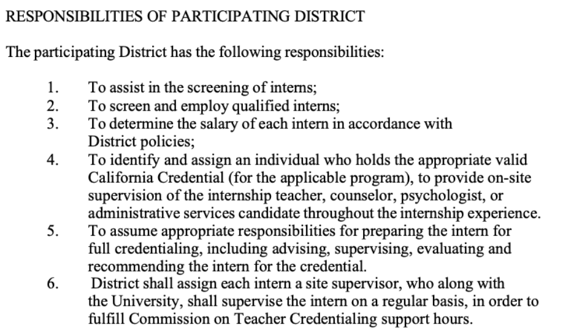

The combined support provided by the University Supervisor and district support provider results in 189 hours of support and supervision annually, which exceeds the Commission requirement of 144 hours plus 45 hours specific to English learner support.

Intern supervision includes:
- Six observations conducted by the University Supervisor
- Additional observations conducted by the site support provider
- Lesson analysis and reflective conferencing
- Ongoing mentoring and instructional guidance

Completion of supervision hours and weekly supervisor visits are documented using the:

- Intern Support and Supervision Log:
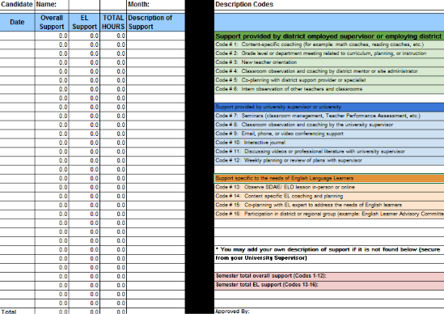

(6) Assignment and Authorization
To receive program approval, the participating institution authorizes the candidates in an internship program to assume the functions that are authorized by the regular standard credential. Reference: Education Code Section 44454. The institution stipulates that the interns' services meet the instructional or service needs of the participating district(s).
Reference: Education Code Section 44458.

Evidence Required
Copy of MOU with district that states candidates in the internship program to assume the functions that are authorized by the regular standard credential and that the interns’ services meet the instructional or service needs of the participating district(s).

Personnel from each participating district authorize University of La Verne LaFetra College of Education interns to assume the functions that are authorized by the regular standard credential.

This authorization is established through formal partnership agreements between the University and participating districts.

Documentation verifying district authorization and assignment of interns is provided in the:
- University/District Fieldwork Agreement (MOU) (page 2):
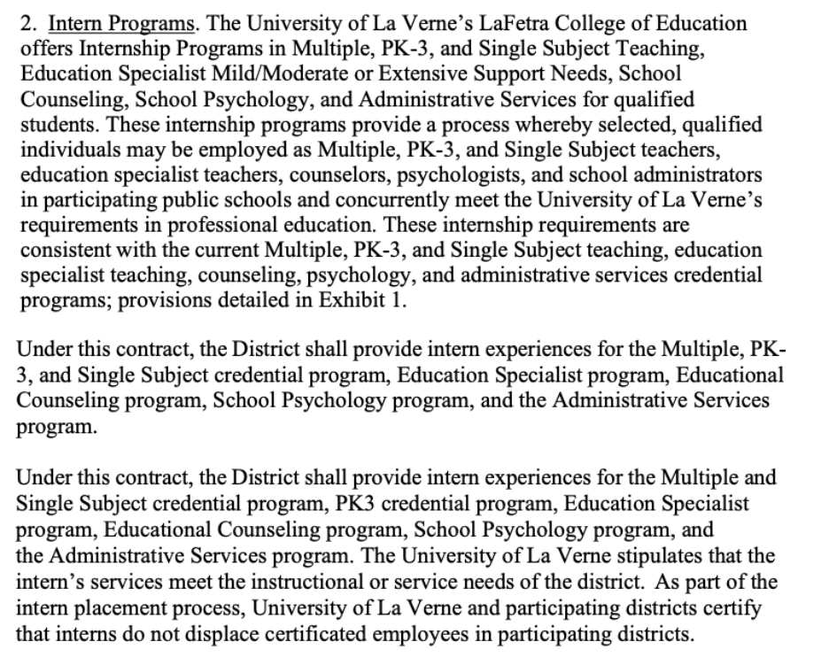
These agreements confirm that intern assignments meet the instructional needs of participating districts and that interns are authorized to perform the duties associated with the appropriate teaching credential while participating in the internship program.

(7) Participating Districts
Participating districts are public school districts or county offices of education. Submissions for approval must identify the specific districts involved and the specific credential(s) involved.
Reference: Education Code Sections 44321 and 44452.

Evidence Required
Provide a list of the school districts or county offices of education in which interns serve.

The University of La Verne LaFetra College of Education places its interns only in public school districts, county offices of education, charter schools or officially designated non-public schools. List of participating districts: Agreements With Districts

Link to Internship Form

Link to Internship Application. The following details the requirements:

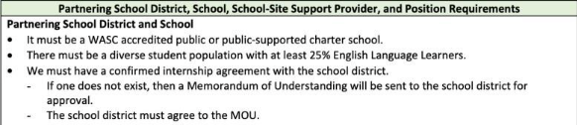

(8) Early Program Completion Option (Not available currently for Education Specialist Interns*)
Each intern program must make available to candidates who qualify for the option the opportunity to choose an early program completion option, culminating in a five year preliminary teaching credential. This option must be made available to interns who meet the following requirements:
- Pass a written assessment adopted by the commission that assesses knowledge of teaching foundations as well as all of the following:
  - Human development as it relates to teaching and learning aligned with the state content and performance standards for K-12 students
  - Techniques to address learning differences, including working with students with special needs
  - Techniques to address working with English learners to provide access to the curriculum
  - Reading instruction in accordance with state standards
  - Assessment of student progress based on the state content and performance standards
  - Classroom management techniques
  - Methods of teaching the subject fields
- Pass the teaching performance assessment. This assessment may be taken only one time by an intern participating in the early completion option.
- Pass the Reading Instruction Competence Assessment (RICA) (Multiple Subject Credential only).
- Meet the requirements for teacher fitness.
An intern who chooses the early completion option but is not successful in passing the assessment may complete his or her full internship program.
Reference: Education Code Section 44468.

Evidence Required
This option is not currently available for Education Specialist credential interns.
Education Code Section 44468 (a) authorizes the Commission to provide an Early Completion pathway for Education Specialist Mild to Moderate Support Needs candidates. However, at this time, the Commission has not approved an acceptable assessment for Education Specialist credentials in order to implement this option. When the Commission acts to approve an assessment that meets the requirements in statute and that is appropriate for the Education Specialist credentials, this option will be made available. Additionally, the law does not allow an early completion option for candidates in Extensive Support Needs programs.

(9) Length of Validity of the Intern Certificate
Each intern certificate will be valid for a period of two years. However, a certificate may be valid for three years if the intern is participating in a program leading to the attainment of a specialist credential to teach students, or for four years if the intern is participating in a district intern program leading to the attainment of both a multiple subject or a single subject teaching credential and a specialist credential to teach students with mild/moderate disabilities.
Reference: Education Code Section 44325 (b).

Evidence Required
- Link to specific page of handbook, program website, or other authentic program documentation that explains length of validity of the intern certificate.
- Copy of MOU(s) with partnering district(s) that includes length of validity of the intern certificate.

The University of La Verne LaFetra College of Education ensures that each intern serves under a valid intern credential issued by the Commission. Faculty members work with interns to ensure successful program completion within the time limitations established for the intern credential. Credential Analysts monitor candidate progress and verify ongoing eligibility throughout the internship program.

Program policies related to intern credential validity and monitoring of candidate eligibility are documented in the following materials:

- Intern Handbook University of La Verne
- University/District Fieldwork Agreement (page 2):
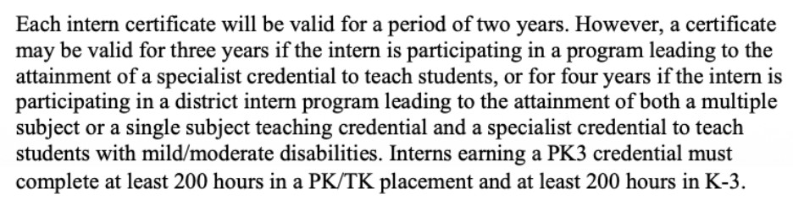

(10) Non-Displacement of Certificated Employees
The institution and participating districts must certify that interns do not displace certificated employees in participating districts.
Reference: Education Code Section 44225.7.

Evidence Required
- Link to specific page of handbook, program website, or other authentic program documentation that states that interns may not displace certificated employees.
- Copy of MOU with district(s) that certifies that interns may not displace certificated employees.

The University of La Verne LaFetra College of Education and its participating districts ensure that interns are placed only in positions that meet district instructional needs and do not replace certificated employees.

This policy is documented in the following program materials:
- Intern Program Handbook
- University/District Fieldwork Agreement (page 2):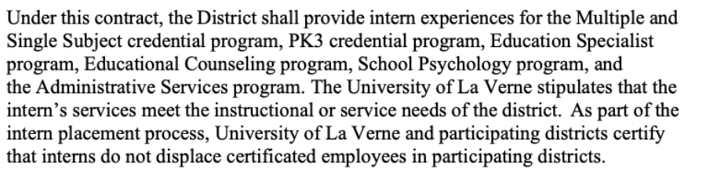

These documents confirm that intern placements comply with state requirements and that interns may not be used to displace certificated employees in participating districts.

(11) Justification of Internship Program
When an institution submits a program for initial or continuing accreditation, the institution must explain why the internship is being implemented. Programs that are developed to meet employment shortages must include a statement from the participating district(s) about the availability of qualified certificated persons holding the credential. The exclusive representative of certificated employees in the credential area (when applicable) is encouraged to submit a written statement to the Committee on Accreditation agreeing or disagreeing with the justification that is submitted.

Evidence Required
Letters of support from partnering district(s) regarding the availability of qualified certificated persons holding the credential in their districts that justify the intern program.

The University of La Verne LaFetra College of Education recognizes an ongoing need for interns in critical teaching areas, including mathematics, the sciences, and special education. The internship programs are designed to support school districts in addressing teacher shortages while preparing qualified candidates to serve in high-need instructional settings.

Through partnerships with local school districts, the University provides an internship pathway that allows qualified candidates to serve as teachers of record while completing their credential preparation program. This pathway helps districts address staffing needs in shortage areas while maintaining program supervision and support for intern teachers.

Therefore, the University of La Verne LaFetra College of Education continues to offer internship programs as a service to both candidates and the districts it serves.

Letters from participating districts verifying the ongoing need for intern teachers and supporting continuation of the internship program are provided in the following documentation:
- District Letters of Support for Internship Program
Bonita Letter of Support for CTC (Includes both Multiple/Single & MMSN/ESN)
Taft Letter of Support for CTC

(12) Bilingual Language Proficiency
Intern programs must verify that candidates who are dually enrolled in a Bilingual Authorization program have attained a language proficiency level in listening, speaking, reading, and writing the target language that is equivalent to the passing standard on the appropriate CSET: World Languages language examination prior to recommending for the intern credential. This performance level is set at a minimum of ACTFL AdvancedLow for Western languages and ACTFL Intermediate-High for non-Western languages. Programs must submit evidence to the Commission which demonstrates how the program ensures that candidates meet the requirement. Reference: Education Code Section 44325(c)(4).

Evidence Required
This precondition is applicable only for programs that have been approved to offer a Bilingual Authorization program. Programs not approved to offer a Bilingual Authorization program may not place candidates in bilingual settings.
- Link to program website or candidate handbook with program requirements indicating that language competence must be met prior to being recommended for the intern credential for candidates who are dually enrolled in a bilingual authorization and intern program.
- Program checklist or equivalent that demonstrates how and when the program verifies the candidate has met the language competence requirement.

Teacher intern candidates at the University of La Verne who are dually enrolled in the Bilingual Authorization program must pass the language proficiency subtest of the Commission-approved assessment program prior to beginning classroom teaching as an intern.

Language proficiency 0verification occurs prior to recommendation for the Intern Credential and is documented through candidate assessment records and credential analyst review.

Program requirements related to bilingual authorization and language proficiency are documented in the following program materials:

- Bilingual Authorization Program Requirements Page
- Intern Program Handbook
- Credential Analyst Verification Checklist
- BILA Checklist

