Preconditions for Education Specialist Programs
Education Specialist: All Added Authorizations
- Candidates accepted into an Added Authorization program must currently hold a preliminary education specialist teaching credential or be eligible for a preliminary education specialist teaching credential prior to recommendation for the Added Authorization.

Candidates accepted into an Added Authorization program must currently hold a Preliminary Education Specialist teaching credential or be eligible for a Preliminary Education Specialist teaching credential prior to institutional recommendation for the Added Authorization.

For the Early Childhood Special Education Added Authorization, candidates must hold a Preliminary Education Specialist credential in Mild/Moderate or Moderate/Severe or be eligible for the same credential prior to institutional recommendation.

The University of La Verne verifies the prerequisite credential prior to institutional recommendation.

Admissions requirements are published in the University Catalog:
https://catalog.laverne.edu/lafetra-college-education/graduate/special-education-program/early-childhood-special-education-added-authorization/#admissionstext

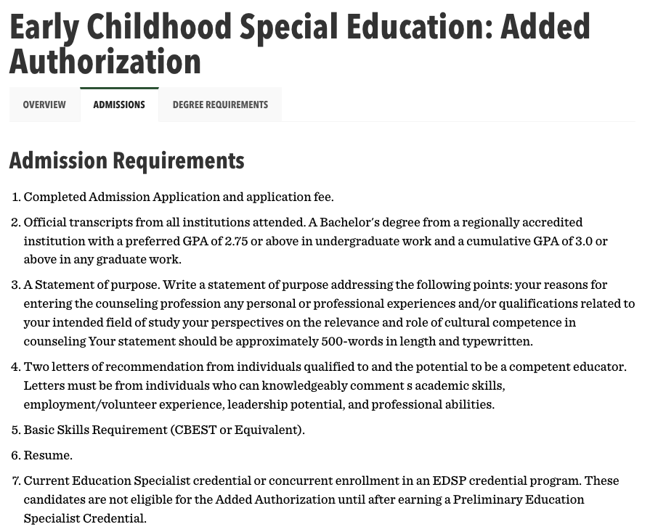

(2) The Added Authorization courses may be considered part of coursework for completing the Clear Education Specialist program.

Added Authorization coursework may be considered part of coursework for completing the Clear Education Specialist program.

As stated in the University Catalog:

“The Early Childhood Special Education courses are also available for those interested in taking the course sequence for professional development or as electives in a related graduate degree program. These students are not eligible for the Added Authorization until after earning a Preliminary Education Specialist credential. All students must complete field work hours in the state of California.”

Catalog Evidence: https://catalog.laverne.edu/lafetra-college-education/graduate/special-education-program/early-childhood-special-education-added-authorization/#text

Early Childhood Special Education Added Authorization

- Candidates accepted into the Early Childhood Special Education Added Authorization program must currently hold a preliminary education specialist teaching credential Mild/Moderate or Moderate/Severe or be eligible for the same education specialist teaching credential prior to recommendation for the Early Childhood Special Education Added Authorization.

Candidates accepted into the Early Childhood Special Education Added Authorization program must currently hold a Preliminary Education Specialist teaching credential in Mild/Moderate or Moderate/Severe or be eligible for the same Education Specialist teaching credential prior to institutional recommendation for the Early Childhood Special Education Added Authorization.

The University of La Verne LaFetra College of Education verifies that candidates admitted into the ECSE Added Authorization program hold the appropriate Preliminary Education Specialist credential prior to institutional recommendation.

Admissions Criteria
Admissions requirements for the Early Childhood Special Education Added Authorization program are published in the University Catalog:
https://catalog.laverne.edu/lafetra-college-education/graduate/special-education-program/early-childhood-special-education-added-authorization/#admissionstext

The catalog clearly states that candidates must hold the appropriate Preliminary Education Specialist credential prior to eligibility for the Added Authorization.

