Preconditions for Bilingual Authorization Program

- Prerequisite Credential
An institution operating a program for the Bilingual Authorization must verify, prior to recommending a candidate for the authorization, that the candidate holds a prerequisite credential or is recommended for a prerequisite credential simultaneously. The prerequisite credential must include an English Learner authorization or the candidate must be eligible for an English Learner authorization pursuant to the provisions of Education Code section 44253.4(b)(1) and 5 California Code of Regulations (CCR) sections 80015.1(a)(1) and 80015.2.
Acceptable prerequisite credentials include a valid California teaching credential, services credential(s) with the added special class authorization, visiting faculty permit, child development permit (excluding assistant and associate permit), or children’s center permit which credential or permit authorizes the holder to provide instruction to pupils in preschool, kindergarten, any of grades 1 to 12, inclusive, or classes primarily organized for adults, except for the following: emergency credentials or permits, exchange credentials as specified in Education Code section 44333, district intern credentials as specified in education code section 44325, sojourn certificated employee credentials as specified in Education Code section 44856, and teacher education internship credentials as specified in Education Code Article 3 (commencing with Education Code section 44450) of Chapter 3.

Examples of Acceptable Evidence
- Link to admission requirements on program website that indicates candidates for the Bilingual Authorization must hold a prerequisite teaching credential or earn the prerequisite credential simultaneously with an English Learner Authorization or be eligible for an English Learner Authorization.
- Checklist or tracking document showing how and when the program verifies the candidate holds the prerequisite credential, or has earned the prerequisite credential simultaneously, and that the credential includes an English Learner Authorization or that the candidate is eligible for an English Learner Authorization.

In accordance with Education Code §44253.4(b)(1) and Title 5 CCR §§80015.1(a)(1) and 80015.2, the University of La Verne verifies prior to institutional recommendation that each candidate for the Bilingual Authorization:

- Holds a valid prerequisite credential, or
- Is recommended for a prerequisite credential simultaneously.

The prerequisite credential must include an English Learner Authorization, or the candidate must be eligible for an English Learner Authorization pursuant to statute and regulation.

Acceptable prerequisite credentials include a valid California teaching credential or other qualifying credential/permit authorizing instruction to pupils in preschool, kindergarten, grades 1–12, adult classes, or qualifying services credentials, consistent with statute. Emergency permits and excluded credentials (e.g., district intern, exchange, sojourn, teacher education internship credentials) are not accepted.

Admissions Criteria
Admission requirements for the Bilingual Authorization program are published on the program website:
https://catalog.laverne.edu/lafetra-college-education/graduate/bila2/

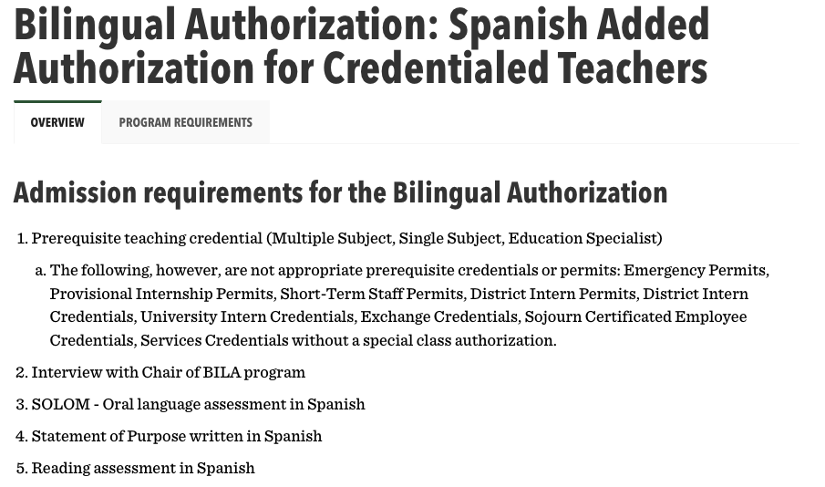

The website clearly states that candidates must hold an appropriate prerequisite credential with English Learner authorization or be eligible to earn the prerequisite credential simultaneously.

Verification Process
Candidates apply through the University’s admissions process and submit documentation verifying:

- A valid prerequisite credential, and
- English Learner authorization (or eligibility for such authorization).

Documentation is submitted through the University’s application system (SLATE) or added as a concentration. The Program Chair and/or Credential Analyst reviews and verifies the prerequisite credential and English Learner authorization prior to institutional recommendation for the Bilingual Authorization.

Verification is documented on the program’s credential recommendation checklist and through the University’s credential review process. Candidates are not recommended for the Bilingual Authorization until verification is complete.

BILA Checklist

